

**IS 610- Business Data Analysis**

**Project Report**

**Topic Name: Regression Analysis**

**Dataset: Student Performance**

**Professor:** Dr. Mohamed Abdelhamid **Students Name:**

Priyanka Chhabra (ID: 032168303)  
Reon Figueiro (ID: 032178196)  
Kunal Jitendra Ghogare (ID: 032195356)  
Pulkit Kamboj (ID: 032258367)  
Parimal Jaykumar Ingle (ID: 032253934)  
Ashutosh Arun Bagal (ID: 032180939)

**Content**

* **Introduction**
* **Methods**
* **Analysis of Descriptives Analysis**
* **Regression Analysis**
* **Study**
* **Additional keyways**
* **Conclusion**
* **References**

**Introduction**

In the realm of educational research, understanding the multifaceted factors that contribute to a student's academic success is crucial for enhancing educational practices and student outcomes. This study delves into a comprehensive dataset aimed at unraveling the intricate web of elements influencing academic performance. The primary objective is to conduct a rigorous regression analysis, employing various independent variables to elucidate their impact on the dependent variable, termed the "Performance Index." This index serves as the pinnacle measure of overall student achievement, acting as the focal point for our investigation. Our independent variables encompass key aspects such as the number of hours dedicated to studying, previous academic scores, participation in extracurricular activities, average sleep hours, and the extent of practice with sample question papers. Through this analysis, we endeavor to unravel the nuanced relationships between these variables and the Performance Index, offering valuable insights into the dynamics that shape students' academic prowess. The ultimate goal is to inform educational strategies and interventions that can positively influence academic outcomes.

**Background of the Context: -**We will be using this dataset and conducting a regression analysis on a dataset that aims to explore the factors influencing academic performance in a group of students. This dataset was collected to understand how variables such as study habits, academic achievement, extracurricular activities, and sleep patterns relate to a student's academic success, as measured by a "Performance Index."

**Methods**

* **Description of Dataset**

1. **Dependent Variable: -**The dependent variable is the focus of our analysis. It's the outcome or result that we are trying to predict, explain, or understand. In your dataset, the Performance Index serves as the dependent variable. This is the measure of overall student performance, and it's the value we are interested in explaining or predicting.
2. **Independent Variables: -**Independent variables are the factors or features that we believe might influence or contribute to changes in the dependent variable.

In our dataset, you have several potential independent variables:

* **Hours Studied: -**The number of hours a student dedicates to studying.
* **Previous Scores: -**The scores a student has achieved in previous assessments.
* **Extracurricular Activities: -**Whether a student is involved in extracurricular activities or not.
* **Sleep Hours: -**The average number of hours a student sleeps.
* **Sample Question Papers Practiced: -**The number of practice question papers a student has completed.

These independent variables are the inputs into our analysis. We will now explore how changes or variations in these factors relate to changes in the dependent variable, the Performance Index.

* **Measurement Scale and Definition**

A) **Dependent Variable:**

* Performance Index:
  + Scale: Continuous (Ratio)
  + Definition: Overall student performance measure, higher values indicate better performance.

B) **Independent Variables:**

* Hours Studied:
  + Scale: Continuous (Ratio)
  + Definition: Time dedicated to studying.
* Previous Scores:
  + Scale: Continuous (Interval)
  + Definition: Past assessment scores.
* Extracurricular Activities:
  + Scale: Categorical (Nominal)
  + Definition: Participation in extracurricular activities.
* Sleep Hours
  + Scale: Continuous (Ratio)
  + Definition: Average hours of sleep.
* Sample Question Papers Practiced:
  + Scale: Continuous (Ratio)
  + Definition: Number of practiced question papers.

**Analysis of Descriptive Analysis**

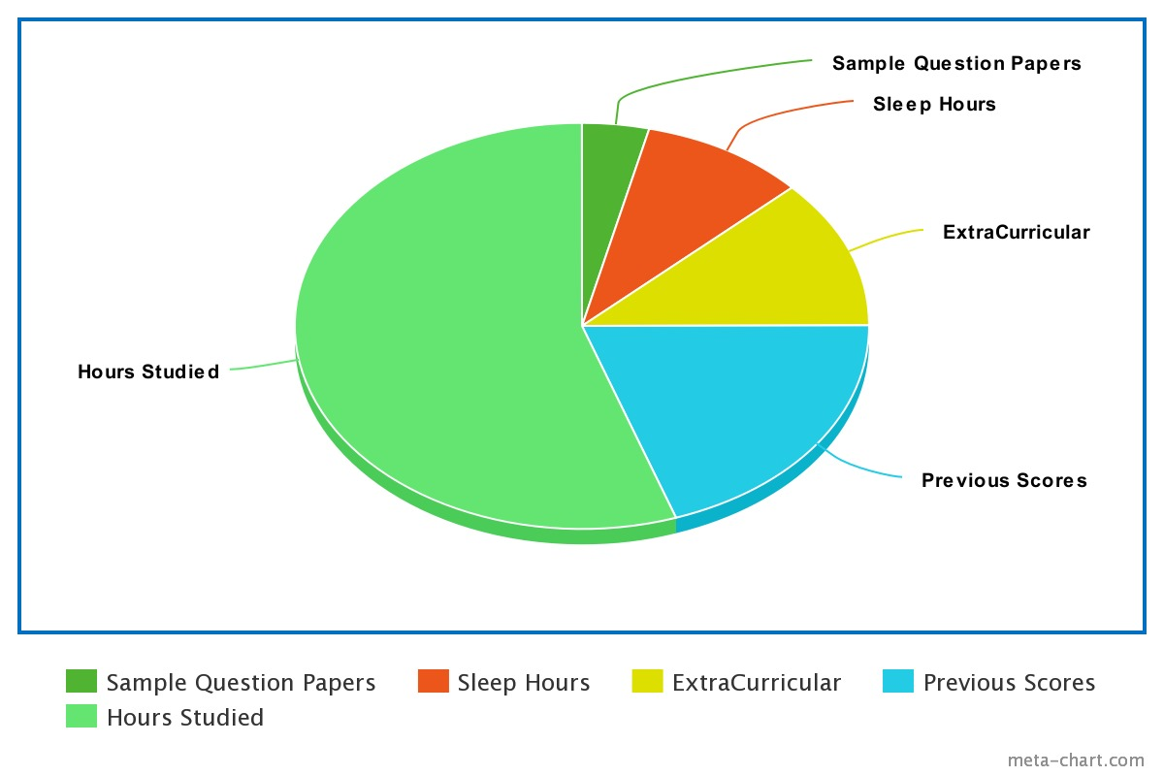

* **Hours Studied: -**We observe that, on average, students spent about 4.92 hours studying, with variations ranging from 1 to 9 hours. The standard deviation of 2.602 suggests a moderate level of variability in the hours students dedicate to studying.

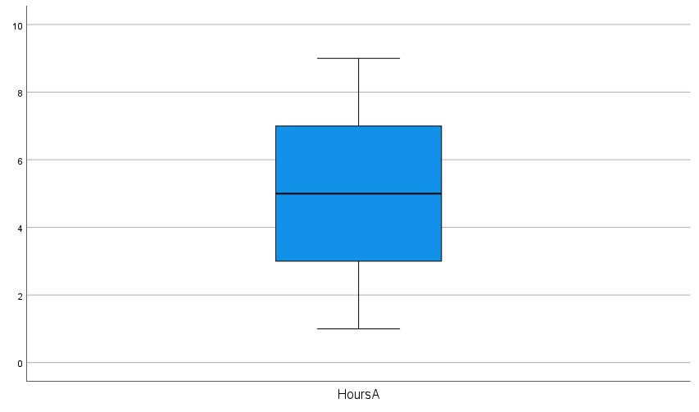

* **Previous Scores: -** The average previous score among the students is 70.21, with individual scores ranging from 40 to 99. The standard deviation of 17.358 suggests a notable spread in the student's previous performance.

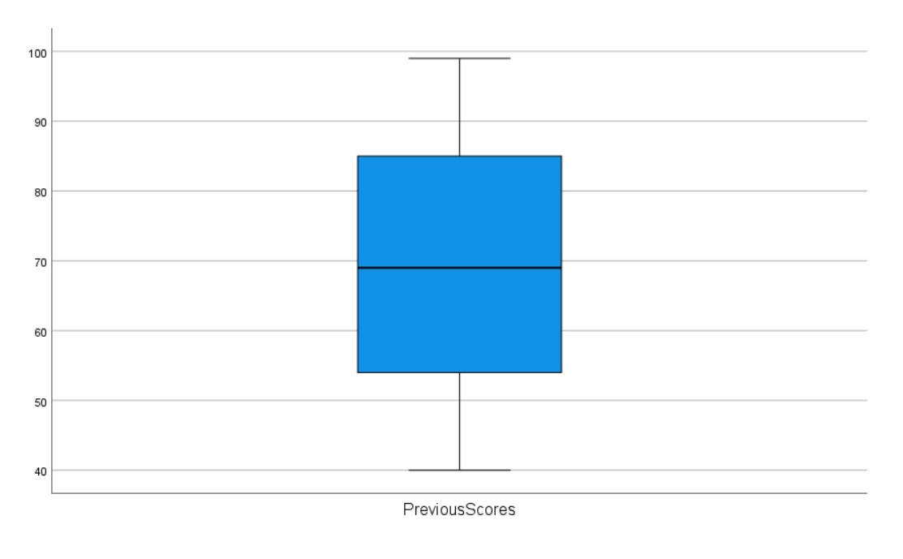

* **Sleep Hours: -** Students reported an average of 6.36 hours of sleep, with individual sleep hours ranging from 4 to 9. The standard deviation of 1.718 indicates variability in the reported sleep durations.

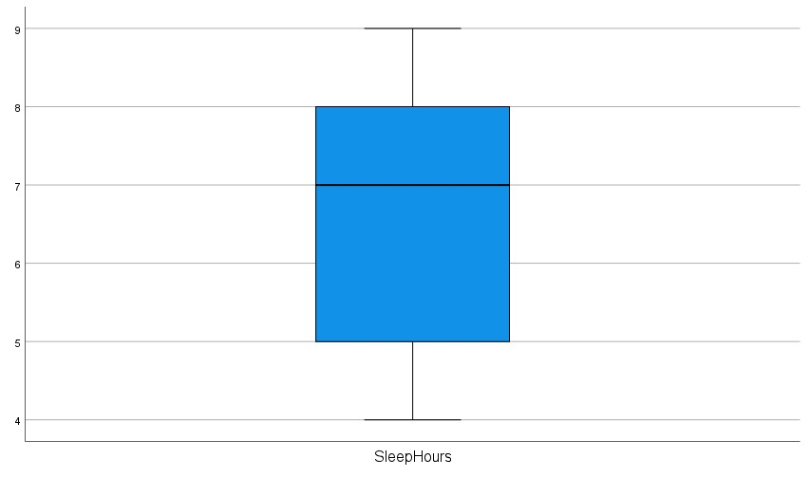

* **Sample Question Paper Practiced: -** On average, students practiced 4.35 sample question papers, with the number of papers practiced ranging from 0 to 9. The standard deviation of 2.842 indicates variability in the amount of practice students engaged in.

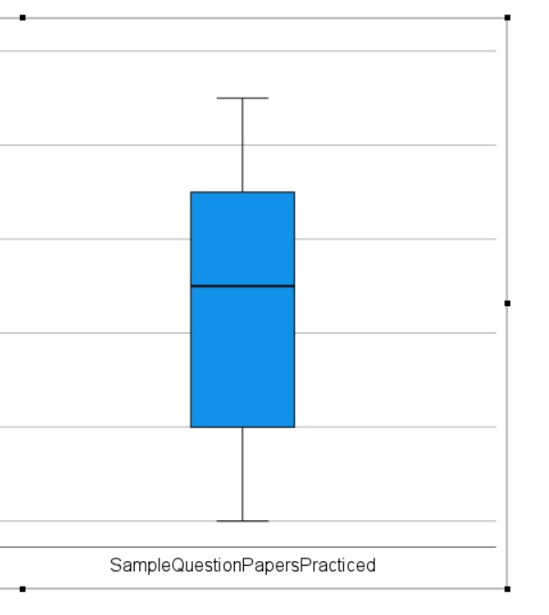

* **Performance Index: -** The average performance index is 55.58, with individual performance index values ranging from 10 to 100. The standard deviation of 19.495 reflects variability in the overall performance of students.
* **Extracurricular Activities: -** On average, approximately 51% of students are involved in extracurricular activities. The recoded values of 0 and 1 indicate the absence or presence of extracurricular activities, with a low standard deviation of 0.501, suggesting limited variability in participation.

**Regression Analysis**

The R Square value of 0.991 tells us that almost 99.1% of the factors influencing a student's academic performance are accounted for by the chosen variables like extracurricular activities, sleep hours, previous scores, practice with sample papers, and study hours. In simpler terms, the model does an excellent job of explaining and predicting a student's performance. This high R Square indicates that these selected factors play a crucial role in understanding and forecasting academic success. It's like having a very accurate map that guides us through the landscape of student achievement, helping us see and predict the whole picture with remarkable accuracy. In the second output, the ANOVA table tells us how far data point is from the regression line.

The value of the coefficient reflects the amount of change in the predicted preference ranking. The sign of the coefficient indicates whether the predicted response increases or decreases when the predictor increases, all other predictors being constant.

From the coefficients, we could see that previous Scores have a higher Beta coefficient. Hence, Previous scores have the highest influence on the performance Index of the student.

**Performance Index = (−34.297) + (2.878×hours Studied) + (1.023×previous Scores) + (0.427×sleep Hours) + (0.215×sample Question Papers Practiced) + (0.507×recoded Extra Curricular Activities)**

**Unlocking Success: What Our Study Revealed About Performance**

* **Powerful Predictors: -**
* **Hours Studied: -**Every extra hour of study boosts the Performance Index significantly (2.878).
* **Previous Scores: -**Past performance strongly influences current results (1.023).
* **Secondary Influences: -**
* **Sleep Hours: -**While important, extra sleep contributes less (0.427).
* **Sample Papers Practiced: -**Practicing more papers helps, but the impact is moderate (0.215).
* **Extracurricular Activities: -** Participation matters (0.507), but its impact on performance is relatively modest.
* **Relative Importance: -**Previous Scores (Beta = 0.911) and Hours Studied (Beta = 0.384) are the most influential factors.
* **Overall Significance: -**The entire model is strong, explaining a lot about what affects the Performance Index.

**Takeaways: -**

* Teachers and students can use these findings to improve strategies.
* Prioritize study hours.
* Leverage past performance for better results. Understanding these factors can lead to a more strategic and effective approach to achieving a higher Performance Index.

**Exploring Additional Keys to Academic Excellence**

In addition to the variables already considered in the regression analysis, several other factors can potentially influence and help students improve their academic performance:

* **Self-Motivation: -** Encouraging self-motivation is key. Students who truly enjoy learning are more likely to put time and effort into their studies.
* **Effective Study Techniques: -** Offering advice on effective study methods, like active recall, spaced repetition, and summarization, can assist students in making the most of their study time.
* **Learning Preferences: -**Understanding individual learning preferences (e.g., visual, auditory) enables students to tailor their study methods to suit their strengths.
* **Healthy Lifestyle: -**Encouraging a balanced lifestyle, including regular exercise, proper nutrition, and sufficient sleep, contributes to overall well-being and cognitive function.
* **Effective Notetaking: -**Teaching students how to take organized and effective notes during lectures and while reading can enhance information retention and understanding.
* **Utilization of Resources: -**Guiding students on how to effectively use available resources, such as textbooks, online materials, and academic support services, can enhance their learning experience.
* **Time Management Skills: -**Providing tools and techniques for effective time management, including setting priorities and creating study schedules, helps students balance academic and personal commitments.
* **Critical Thinking Skills: -**Encouraging the development of critical thinking skills promotes a deeper understanding of subjects and helps students approach problems more analytically.
* **Emotional Intelligence: -** Building emotional intelligence can aid students in handling stress, navigating relationships, and developing resilience in the face of challenges.
* **Goal Setting and Planning: -**Assisting students in setting realistic and achievable academic goals and creating action plans can provide direction and motivation.
* **Active Participation in Class: -**Actively engaging in class discussions, asking questions, and seeking clarification can enhance comprehension and retention of course material.
* **Seeking Help When Needed: -**Encouraging students to seek assistance from teachers, tutors, or peers when facing difficulties can prevent the accumulation of gaps in understanding.
* **Effective Test-Taking Strategies: -**Providing guidance on test-taking strategies, including time management during exams and approaches to different question types, can improve performance in assessments.
* **Curiosity and Exploration: -**Encouraging a sense of curiosity and a willingness to explore topics beyond the curriculum can foster a lifelong love of learning.

Educators and institutions can enhance student success by addressing these factors. This involves not just academic knowledge but also fostering essential skills and habits for lifelong learning.

**Conclusion**

The study identified powerful predictors of academic success, emphasizing the critical roles of study hours and previous performance. The beta coefficients underscored the significant impact of an extra hour of study and the enduring influence of past scores on current academic outcomes. While sleep hours, sample paper practice, and participation in extracurricular activities were found to be secondary influences, their contributions, although moderate, were acknowledged.

The relative importance analysis highlighted that previous scores and study hours were the most influential factors, reinforcing the idea that building on past performance and dedicating ample time to study is paramount for achieving academic excellence.

Moreover, the report delves beyond the analyzed variables, exploring additional keys to academic excellence. The suggested interventions encompass self-motivation, effective study techniques, consideration of learning preferences, promotion of a healthy lifestyle, and the development of various skills such as critical thinking and time management.

In essence, this project contributes not only to the academic understanding of student performance but also offers a holistic approach to fostering lifelong learning habits. Educators and institutions can play a pivotal role in enhancing student success by addressing the multifaceted aspects identified in this study, guiding students not only in academic knowledge but also in developing the essential skills and habits necessary for a sustained and fulfilling educational journey. This report stands as a valuable resource for shaping educational policies and practices aimed at nurturing well-rounded and successful students.

**References/Citations**

* *7 tips to help you achieve academic success*. 7 tips to help you achieve academic success | Penn LPS Online. (2023, January 11). <https://lpsonline.sas.upenn.edu/features/7-tips-help-you-achieve-academic-success>
* *8 steps to academic success*. 8 Steps to Academic Success | Academic Advising & Career Centre. (n.d.). <https://www.utsc.utoronto.ca/aacc/8-steps-academic-success>
* *About linear regression*. IBM. (n.d.). <https://www.ibm.com/topics/linear-regression>
* Narayan, N. (2023, June 29). *Student performance (multiple linear regression)*. Kaggle. <https://www.kaggle.com/datasets/nikhil7280/student-performance-multiple-linear-regression/data>